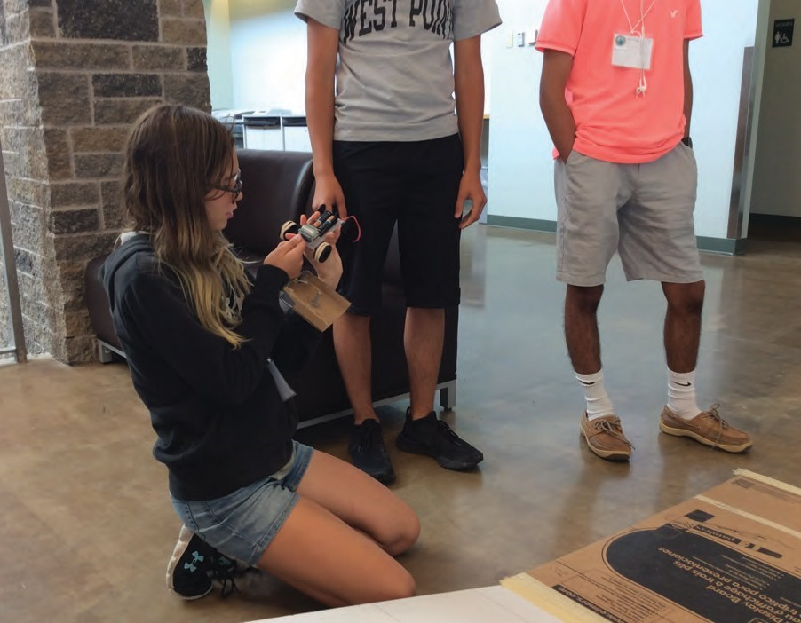

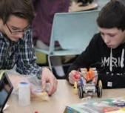

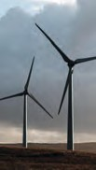 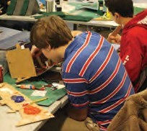 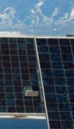 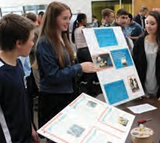

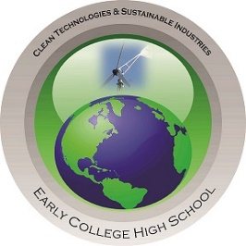

CLEAN TECHNOLOGIES & SUSTAINABLE INDUSTRIES

**EARLY COLLEGE HIGH SCHOOL PROGRAM**

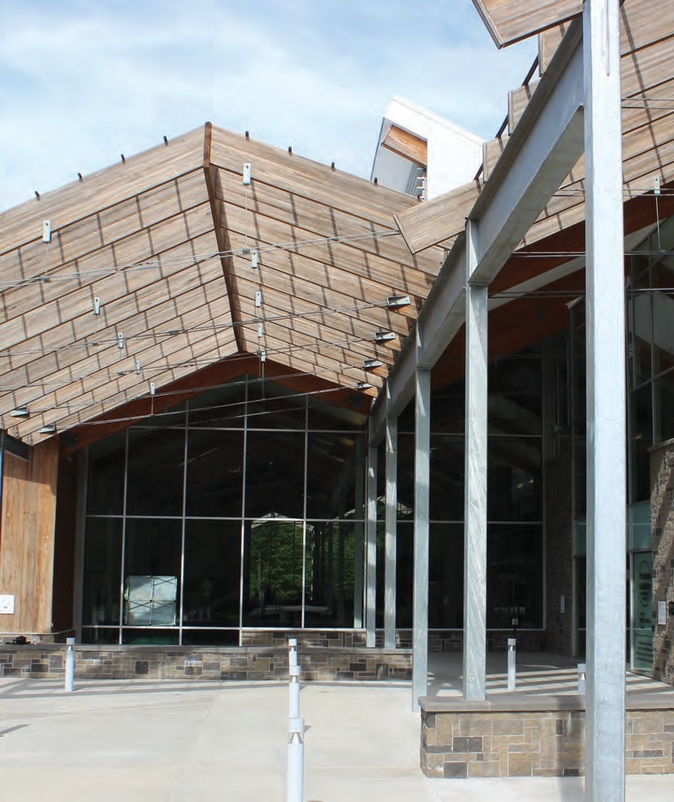

REAL WORLD EXPERIENCE  
Collaborating with business partners, such as GLOBALFOUNDRIES, prepares students for advanced manufacturing jobs making products that enable current technologies.

**CLEAN TECHNOLOGIES SUSTAINABLE INDUSTRIES**

**Providing high school students with opportunities to develop college and career readiness skills and pursue college coursework**

|  |  |
| --- | --- |
| Program  Location | HVCC’S  TEC-SMART  345 Hermes Road  Malta, NY 12020 |
| Program  Support | NYS P-TECH Grant Corporate Partner Donations |
| Scholarship  Offerings | Sage College  Siena College  University at Albany |

**EARLY COLLEGE HIGH SCHOOL PROGRAM**

Early College High Schools blend high school and college in a rigorous yet supportive program, compressing the time it takes to complete a high school diploma and the first two years of college.

Launched in the 2011-2012 school year in collaboration with NYSERDA and Hudson Valley Community College at TEC-SMART in Malta, NY, the Clean Technologies & Sustainable Industries ECHS Program, a Pathways in Technology (P-TECH) Program, provides high school students with opportunities to develop college and career readiness skills and pursue college coursework in one of seven pathways.

The Clean Tech ECHS program includes partners from K-12 education, higher education, and business & industry collaborating together to provide students a distinct opportunity to pursue coursework towards an Associate’s Degree and be prepared to seamlessly transition into key industry sectors within our economic region.

**COLLEGE PATHWAYS**

The ECHS program develops and supports pathways to higher education leading to careers in STEM-related fields. High School students pursue college coursework in one of seven pathways and gain up to 32 credits.

*Students take Hudson Valley Community College coursework at TEC-SMART in 1 of 7 pathways:*

* **Clean Energy Management**
* **Community and Public Health**
* **Hacking and Cybersecurity**
* **Engineering Sciences**
* **Entrepreneurship**
* **Polysomnography**
* **Surgical Technology**

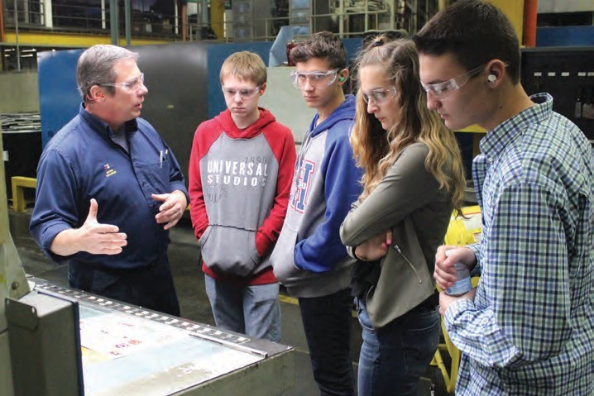

|  |  |  |  |  |
| --- | --- | --- | --- | --- |
| ***Number of Participating Students*** |  | ***College  Acceptance  Rate*** |  | ***Participating  School  Districts*** |
|  |  |  |  |  |
| **243** |  | **100%** |  | **15** |

|  |  |
| --- | --- |
| ***STUDENT CHARACTERISTICS*** | |
| * Motivated to learn in new and exciting ways | * Willing to persevere |
| * Interested in science, technology, engineering, and math | * Being a risk taker |
|  | * Innovative and creative |

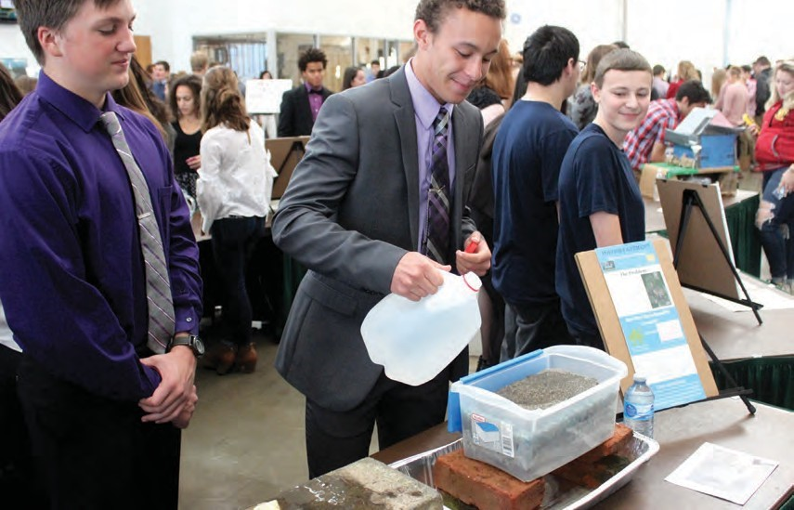

**PROGRAM OVERVIEW**

Our vision is to cultivate a fully connected and collaborative learning environment focusing on 21st Century Skills, STEM teaching and learning, and college and career readiness for all students that is supported through public and private partnerships. The program provides equity and access for all students. Student have the opportunity to achieve the diploma Seal of Civic Readiness.

**Students earn concurrent high school and college credits**

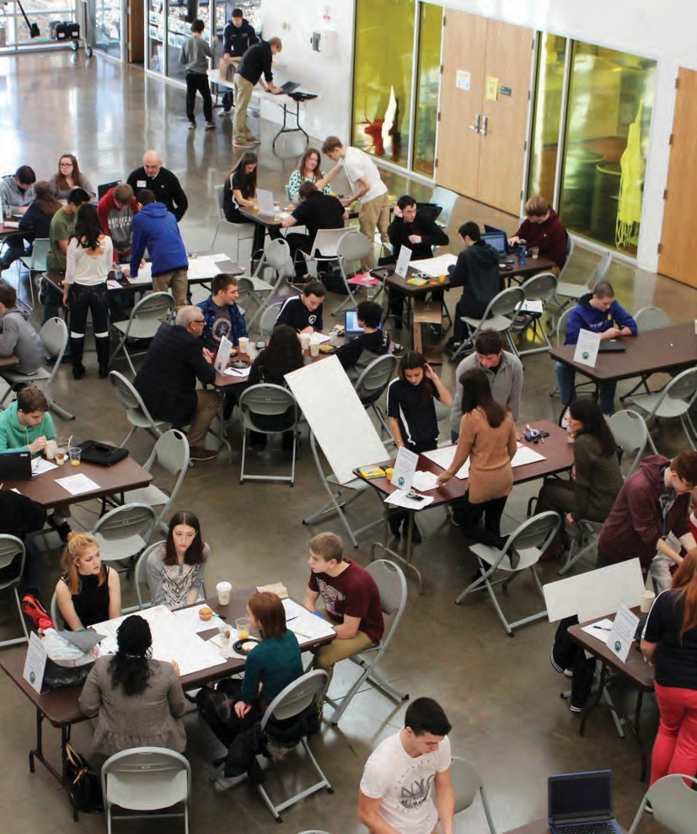

## **11th Grade**

* Students attend school at TEC-SMART for high school and college classes in the morning, returning to their home school in the afternoon
* High school coursework includes English 11, Applied Mathematics in Clean Technologies, Environmental Science & Sustainability, and P-TECH Reading and Research
* HVCC coursework includes one to two courses each semester based on pathway

## **9th Grade**

* Students enroll in high school coursework at their home schools
* ECHS online coursework includes 21st Century Skills
* Monthly visits to TEC-SMART with mentoring

## **12th Grade**

* Students attend school at TEC-SMART for high school and college classes in the morning, returning to their home school in the afternoon
* High school coursework includes CHS English Composition, Intro to Nanotechnology, and Green Economics & Public Policy
* HVCC coursework includes one to two courses each semester based on pathway

## **11th Grade**

* Students attend school at TEC-SMART for high school and college classes in the morning, returning to their home school in the afternoon
* High school coursework includes English 11, Applied Mathematics in Clean Technologies, Environmental Science & Sustainability, and P-TECH Reading and Research
* HVCC coursework includes two courses each semester based on pathway

## **10th Grade**

* Students enroll in high school coursework at their home schools
* ECHS online coursework includes a combination of 21st Century Skills, Civics, and Workplace Readiness
* Monthly visits to TEC-SMART with mentoring

|  |  |
| --- | --- |
| **School Environment** | |
| * Upperclassmen mentor freshman and sophomore students | * Students attend college classes taught by college professors at HVCC’s TEC-SMART |
| * Business partners work with students on their projects | * Student committees work on events and student life |
|  | * Students organize community service events |
| **The Learning** | | |
| * Trans-disciplinary problem-based learning | * Job Shadowing and field experience | |
| * Given a task prompt, students collaborate to complete the task by creating a product | * Students are evaluated by business partners in a “Shark Tank” environment on their real-world application of solutions | |
| * 1:1 technology environment |  | |

**11th Grade Coursework**

Students attend school at TEC-SMART for high school and college classes in the morning, returning to their home school in the afternoon.

**High School Coursework**

English 11 – 1.0 High School Credit  
*Students sit for NYS Common Core English Exam at their home school*  
Applied Mathematics in Clean Technologies – 1.0 High School Credit  
*All high school courses are NCAA approved except for Applied Mathematics in Clean Technologies*

Environmental Science & Sustainability – 1.0 High School Credit

P-TECH Reading & Research – Online Course – .5 High School Credit

**Career Exploration**Students will complete an approximate 40-hour work-based learning experience during their junior or senior year. This experience is intended to be a highly structured, career preparation activity in which students are placed at a workplace for a defined period of time to participate in and observe work first hand within a given industry. Work based learning experiences provide the opportunity to learn by doing real work and being productively engaged in the workplace. They may provide the opportunity to work in teams, rotate through a number of departments and job functions, or to work on a project of interest to the student (or group of students) and be a productive value for the employer partner.

They are designed to give students hands-on experience in a field of interest, learn and practice occupational skills, and provide the opportunity to learn about their career options.

**Field Experiences are designed to promote:**

* Exploration of and experience in a field of interest
* Exposure to a wide range of careers and jobs within the industry
* Opportunities to develop and demonstrate new skills
* The acquisition of occupational knowledge
* Awareness of the skills and education needed to be successful in the industry

**12th Grade Coursework**

Students attend school at TEC-SMART for high school and college classes in the morning, returning to their home school in the afternoon.

**High School Coursework**

CHS English Composition – 1.0 High School Credit; 3.0 College Credits  
  
Intro to Nanotechnology – 1.0 High School Credit  
*Can be used for a year of science or technology.*

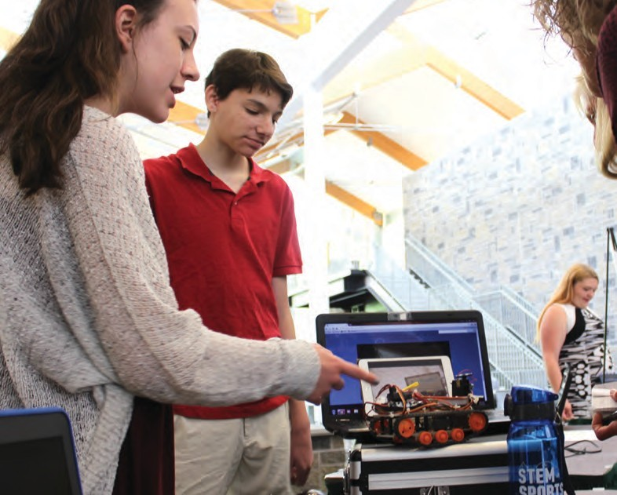Green Economics and Public Policy – 1.0 High School Credit  
*Counts for economics and government credit.*

CLEAN ENERGY

The Clean Energy Management Associate in Applied Science (AAS) degree program combines renewable energy and business courses to meet industry demands for a workforce that possesses a blend of technical skills and business management abilities. In addition to basic electrical theory and an exploration of photovoltaic, geothermal, wind and fuel cell energies, the program focuses on the essential principles of finance, marketing and business development. The interdisciplinary curriculum also provides technical training in PV installation, troubleshooting and maintenance.

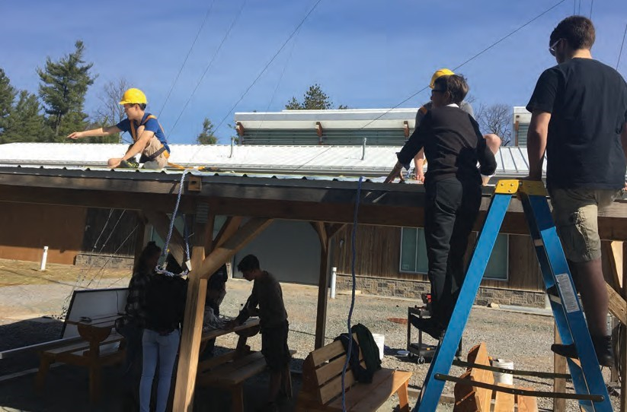

CLEAN ENERGY

**Hudson Valley Community College Coursework**

Junior students take two college courses each semester based on pathway.

Senior students take two college courses each semester based on their junior year pathway.

HVCC college coursework is subject to change based on HVCC enrollment, scheduling, and offerings.

|  |  |  |  |  |  |
| --- | --- | --- | --- | --- | --- |
| **11th Grade** |  |  | **12th Grade** |  |  |
| **FALL** |  |  | **FALL** |  |  |
| Principles of Marketing  Legal & Ethical Environment of Business | |  | Photovoltaic Systems Theory & Design  Electrical Theory for Renewable Energy | |  |
|  | |  | English Composition I |  |  |
|  |  |  |  |  |  |
| **SPRING** |  |  | **SPRING** |  |  |
| College Algebra w/Trig* or Precalculus | | | Photovoltaic Installation & Maintenance | | |
| Intro to Wind Energy | | | Electrical Power Distribution & Control |  |  |

* *Students who are looking to obtain an advanced Regents diploma should also take the high school Algebra II/Trigonometry course at their home school.*

*“My favorite memory from the program was participating in the Kid Wind Competition”*

*- Katherine Champagne*

COMMUNITY & PUBLIC HEALTH



The Community and Public Health (AAS) Degree, an Associate of Applied Science, is for those interested in the field of community health who may have little or no background in the field. Community and Public health navigators educate, motivate and empower their clients. Working under licensed health care professionals, they serve as a liaison between clients and the health care system, connecting clients with services and providing support for those navigating the health care landscape.

Coursework in this program will help students acquire a broad base of knowledge that spans health care, community health, health insurance, human services, health literacy and chronic diseases.

COMMUNITY & PUBLIC HEALTH

**Hudson Valley Community College Coursework**

Junior students take two college courses each semester based on pathway.

Senior students take two college courses each semester based on their junior year pathway.

HVCC college coursework is subject to change based on HVCC enrollment, scheduling, and offerings.

|  |  |  |  |  |  |
| --- | --- | --- | --- | --- | --- |
| **11th Grade** |  |  | **12th Grade** |  |  |
| **FALL** |  |  | **FALL** |  |  |
| General Psychology | |  | Child Psychology | |  |
| Public Speaking | |  | Social Problems |  |  |
|  |  |  | English Composition I |  |  |
|  |  |  |  |  |  |
| **SPRING** |  |  | **SPRING** |  |  |
| Statistics | | | US Healthcare | | |
| Cultural Diversity in American Society | | | Healthcare Ethics |  |  |



HACKING AND CYBERSECURITY

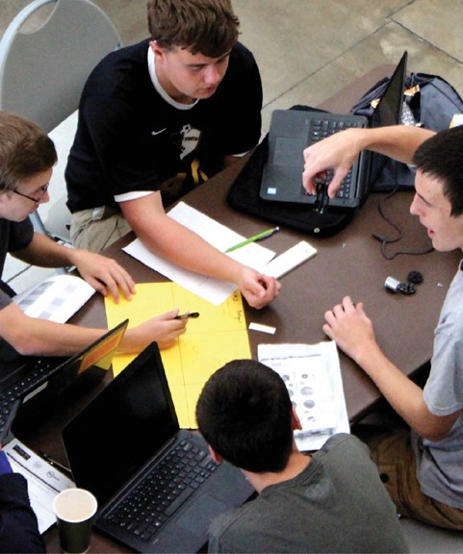

The Hacking and Cybersecurity (AS) program combines criminal justice and computer information systems coursework with a strong base of liberal arts courses to prepare you for transfer into a bachelor’s degree in Digital Forensics, Cybersecurity and other related programs. The college has transfer articulation agreements with the University of Albany, which offers a Digital Forensics BS degree with Alfred State College.

HACKING AND CYBERSECURITY

**Hudson Valley Community College Coursework**

Junior students take two college courses each semester based on pathway.

Senior students take two college courses each semester based on their junior year pathway.

HVCC college coursework is subject to change based on HVCC enrollment, scheduling, and offerings.

|  |  |  |  |  |  |
| --- | --- | --- | --- | --- | --- |
| **11th Grade** |  |  | **12th Grade** |  |  |
| **FALL** |  |  | **FALL** |  |  |
| Intro to Computer Information Sciences  General Psychology | |  | Programming & Logic I  Public Speaking | |  |
|  | |  | English Composition I |  |  |
|  |  |  |  |  |  |
| **SPRING** |  |  | **SPRING** |  |  |
| College Algebra w/Trig or Precalculus | | | Computer & Information Security | | |
| Developmental Psychology | | | Introduction to Criminal Justice |  |  |

* *Students who are looking to obtain an advanced Regents diploma should also take the high school Algebra II/Trigonometry course at their home school.*

*“I chose cybersecurity, because I wanted to protect the future.”*

*- Jacob Rosebrook*

*“The reason I chose the cybersecurity pathway is that it allows me to study a field that isn’t regularly taught in high school, but is very needed in the workforce.”*

*- Tyler Sears*

ENGINEERING SCIENCES

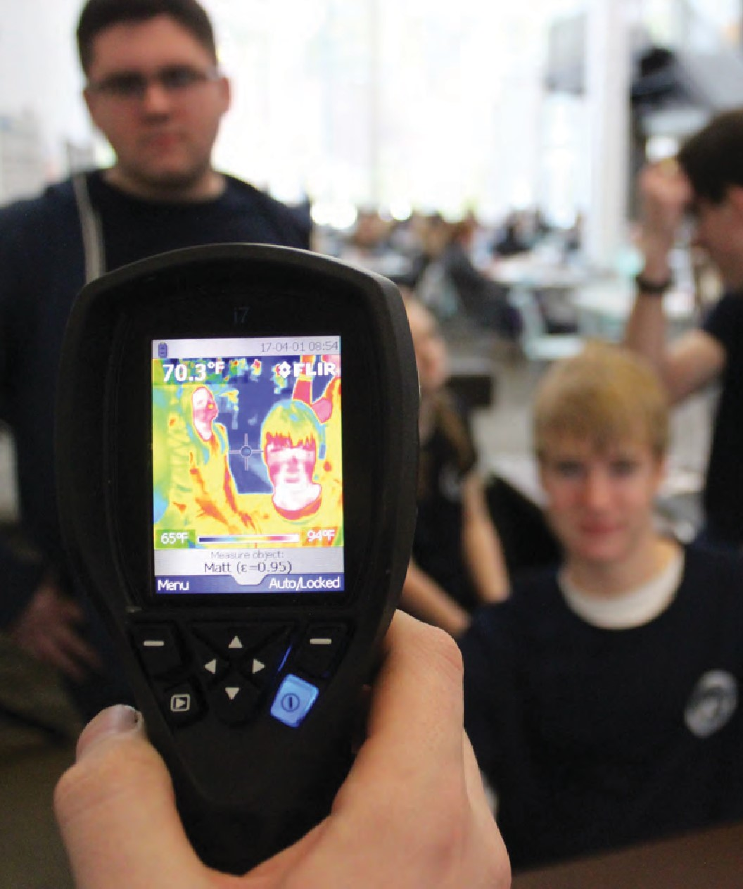

**Hudson Valley Community College Coursework**

Junior students take two college courses each semester based on pathway.

Senior students take two college courses each semester based on their junior year pathway.

HVCC college coursework is subject to change based on HVCC enrollment, scheduling, and offerings.

|  |  |  |  |  |  |
| --- | --- | --- | --- | --- | --- |
| **11th Grade** |  |  | **12th Grade** |  |  |
| **FALL** |  |  | **FALL** |  |  |
| Programming & Logic 1 | |  | English Composition I | |  |
| Introduction to Engineering Design | |  | Calculus I |  |  |
|  |  |  |  |  |  |
| **SPRING** |  |  | **SPRING** |  |  |
| College Precalculus | | | English Composition II | | |
| Engineering Tools or Cultural Diversity in American Society | | | Calculus II |  |  |

* *Students who are looking to obtain an advanced Regents diploma should also take the high school Algebra II/Trigonometry course at their home school.*

ENGINEERING SCIENCES

The Engineering Sciences Associate in Science (AS) degree program parallels the first two years of four-year college programs in various engineering fields. This is a rigorous program of study and each year our graduates having good academic standing transfer to top-tier four-year science or engineering colleges ready to complete the final two years of a bachelor's degree program. Students in this program will take coursework in computer information sciences, engineering design, math and physics. Students in this program regularly transfer to top engineering schools including RPI, Clarkson and SUNY Binghamton and study engineering sub-specialties, such as: biomedical, chemical, civil, computer, environmental, industrial, materials, mechanical, nanoscale and nuclear.

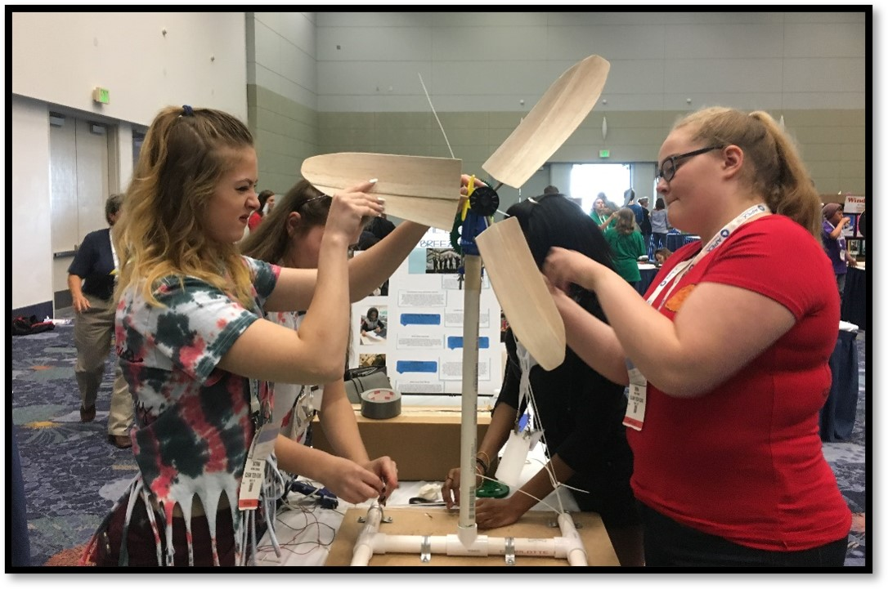

ENTREPRENEURSHIP

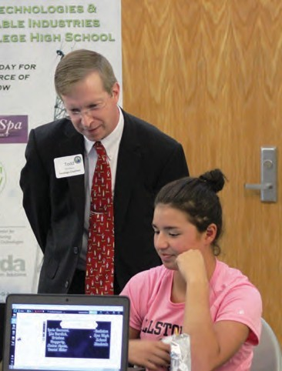

The Entrepreneurship Associate in Applied Science (AAS) degree is for those who are interested in launching a business venture. The Entrepreneurship degree will give you the necessary skills to pursue that dream. You will learn the fundamentals for increasing the likelihood of building sustainable success in your venture. Coursework will help you develop an entrepreneurial mindset, understand entrepreneurial finance, small business management, marketing, and legal issues for small business owners. This academic program is primarily designed for those who wish to enter the workforce immediately following graduation or wish to continue their degree in business.

ENTREPRENEURSHIP

**Hudson Valley Community College Coursework**

Junior students take two college courses each semester based on pathway.

Senior students take two college courses each semester based on their junior year pathway.

HVCC college coursework is subject to change based on HVCC enrollment, scheduling, and offerings.

|  |  |  |  |  |  |
| --- | --- | --- | --- | --- | --- |
| **11th Grade** |  |  | **12th Grade** |  |  |
| **FALL** |  |  | **FALL** |  |  |
| Principles in Marketing | |  | Statistics | |  |
| Introduction to Entrepreneurship | |  | Entrepreneurship Process English Composition I |  |  |
|  |  |  |  |  |  |
| **SPRING** |  |  | **SPRING** |  |  |
| Intermediate Algebra or College Algebra w/Trig, | | | Digital Marketing  Organization and Management | | |
| General Psychology | | |  |  |  |

* *Students who are looking to obtain an advanced Regents diploma should also take the high school Algebra II/Trigonometry course at their home school.*

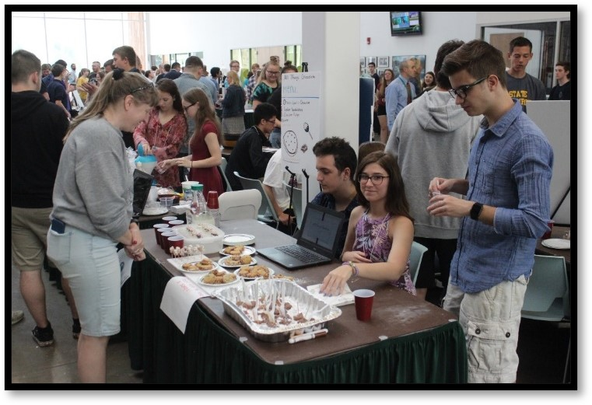

POLYSOMNOGRAPHY

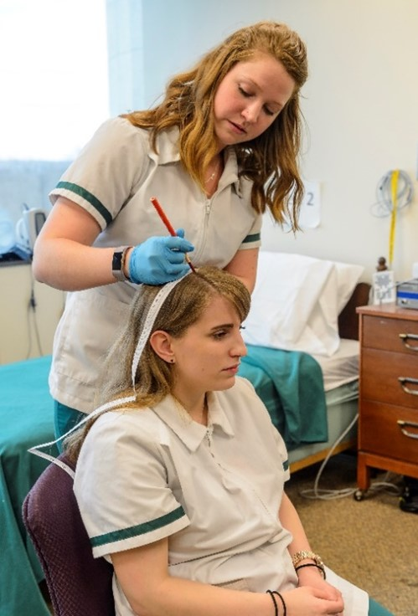

**Hudson Valley Community College Coursework**

Junior students take two college courses each semester based on pathway.

Senior students take two college courses each semester based on their junior year pathway.

HVCC college coursework is subject to change based on HVCC enrollment, scheduling, and offerings.

|  |  |  |  |  |  |
| --- | --- | --- | --- | --- | --- |
| **11th Grade** |  |  | **12th Grade** |  |  |
| **FALL** |  |  | **FALL** |  |  |
| General Psychology | |  | Physics for Health Sciences | |  |
|  | |  | English Composition I |  |  |
|  |  |  | Anatomy & Physiology for Respiratory Care Students | | |
| **SPRING** |  |  | **SPRING** |  |  |
| Statistics  Developmental Psychology | | | Human Anatomy & Physiology  Healthcare Ethics | | |

* *Students who are looking to obtain an advanced Regents diploma should also take the high school Algebra II/Trigonometry course at their home school.*

POLYSOMNOGRAPHY

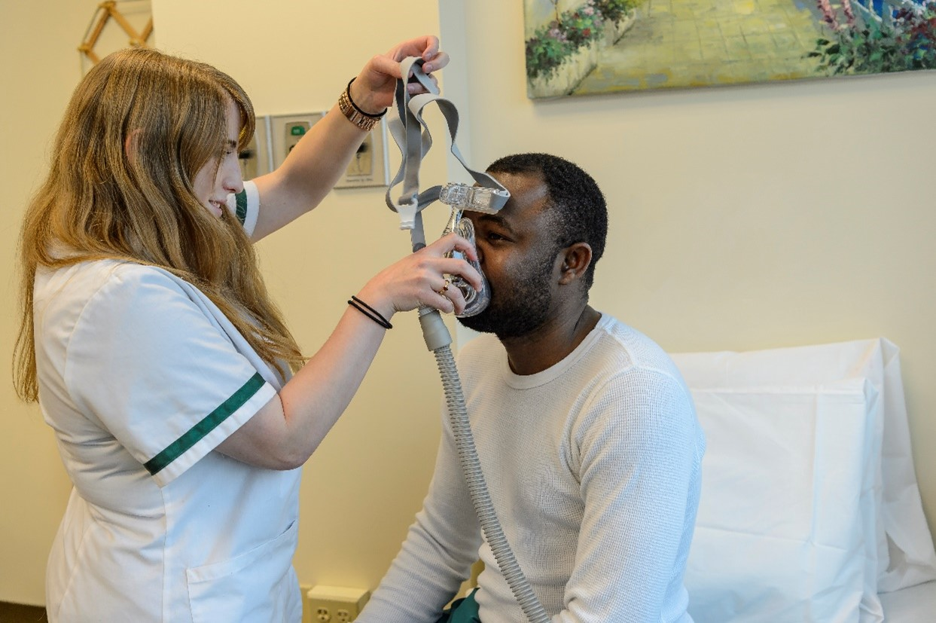

The Polysomnography Associate in Applied Science (AAS) degree program prepares graduates to work in the field of polysomnography OR electroencephalography diagnostic testing. Polysomnography is an allied health specialty that deals with the diagnostic evaluation and management of patients with neurological and sleep abnormalities.

Polysomnography technologists administer sleep tests and work with physicians to provide information needed for accurate diagnosis and treatment.

This degree prepares you for a career as a technician/technologist in the field of polysomnography, which deals with the diagnostic evaluation and management of patients with neurological or sleep abnormalities. There are over 80 different sleep disorders including sleep apnea, narcolepsy and insomnia. You will learn how to operate sophisticated electronic monitoring devices which record brain activity (EEG), muscle and eye movements, blood oxygen levels and physiological events.

Job opportunities may be found in sleep labs and EEG departments OR hospitals OR associated with physician’s offices.

SURGICAL TECHNOLOGY

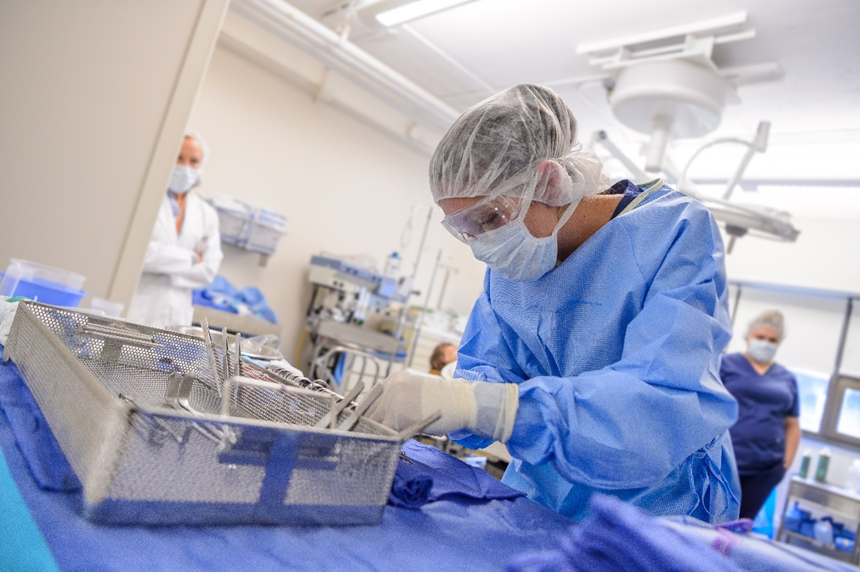

**Hudson Valley Community College Coursework**

Junior students take two college courses each semester based on pathway.

Senior students take two college courses each semester based on their junior year pathway.

HVCC college coursework is subject to change based on HVCC enrollment, scheduling, and offerings.

|  |  |  |  |  |  |  |
| --- | --- | --- | --- | --- | --- | --- |
| **11th Grade** |  |  |  | **12th Grade** |  |  |
| **FALL** |  |  |  | **FALL** |  |  |
| General Psychology | |  |  | Anatomy & Physiology I | |  |
|  | |  |  | English Composition I |  |  |
|  |  |  |  |  |  |  |
| **SPRING** |  |  |  | **SPRING** |  |  |
| College Algebra w/Trig or College Precalculus | | |  | Anatomy & Physiology II | | |
| Developmental Psychology | | |  | English Composition II |  |  |

* *Students who are looking to obtain an advanced Regents diploma should also take the high school Algebra II/Trigonometry course at their home school.*

SURGICAL TECHNOLOGY

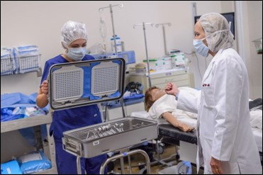

Surgical technologists prepare operating rooms, arrange equipment and help doctors during a range of surgical procedures. They also may be responsible for ensuring aseptic conditions in the operating room, as well as cleaning and preparing all instruments that might be needed during an operation.

This program prepares you for a career as a professional member of a surgical team. Students are involved in lecture and discussion classes as well as clinical learning experiences.

The degree program is ideal for those interested in entering the field of surgical technology and who are looking for an accredited program to gain certification.

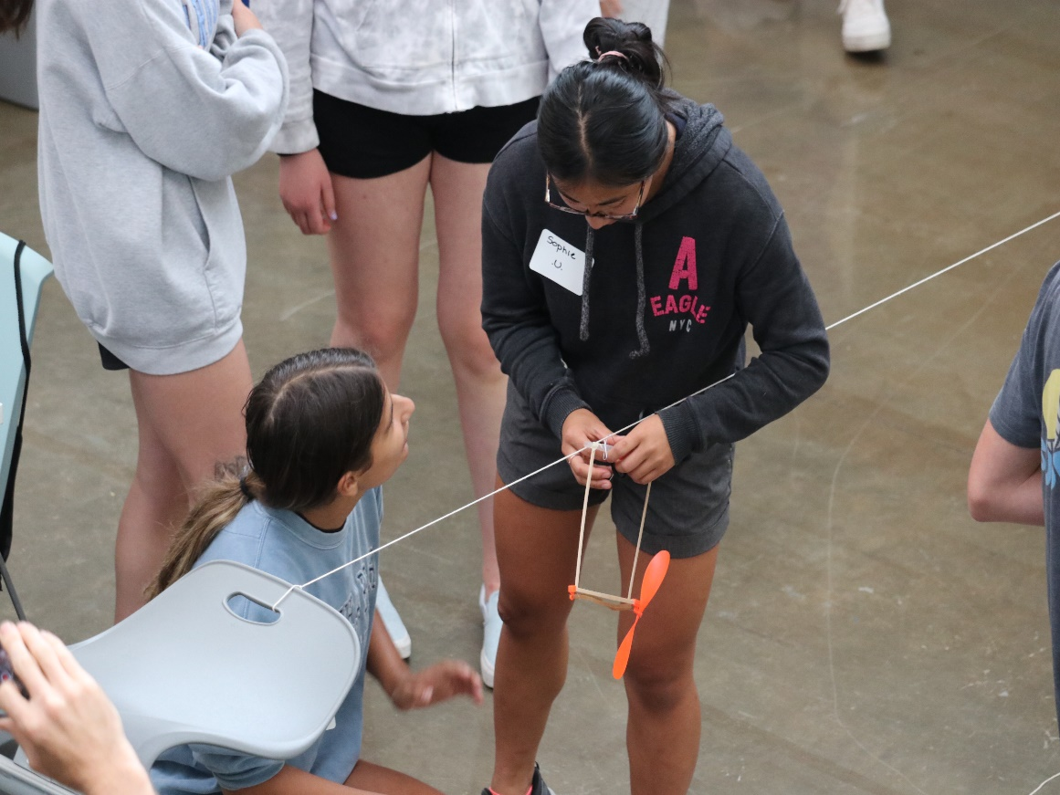

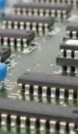 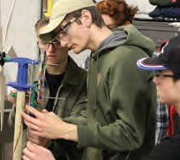 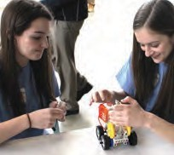 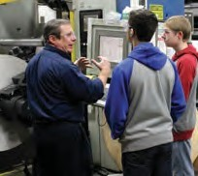 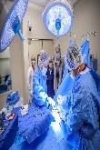

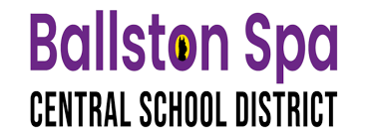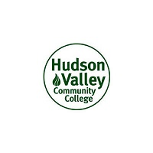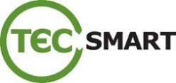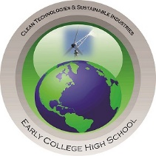 For more information, please visit [www.bscsd.org/Domain/831](http://www.bscsd.org/Domain/831) Follow us on  [@CleanTechECHS](http://twitter.com/CleanTechECHS)  
 Ballston Spa Central School District  
 70 Malta Avenue, Ballston Spa, NY 12020  
 Phone: 518-629-4981

CONTACT US  
For more information, please visit [www.bscsd.org/Domain/831](http://www.bscsd.org/Domain/831)

Follow us on ******[@CleanTechECHS](http://twitter.com/cleantechechs)

Ballston Spa Central School District  
70 Malta Avenue, Ballston Spa, NY 12020

Phone: 518-629-4981